DATA ANALYSIS USING PLOTS

IIT ROPAR


INSTITUTE : INDIAN INSTITUTE OF TECHNOLOGY ,ROPAR

COURSE : INTRODUCTION TO COMPUTING (GE 103)

INSTRUCTOR : Dr. SUDARSHAN IYENGAR

PROJECT : DATA ANALYSIS USING PLOTS

PROJECT IN SHORT: 1) COMPARISON BETWEEN POLLUTION LEVELS IN LARGER CITIES IN THE WORLD

2) ANALYSING THE CONDITION OF INDIAN CITIES AS COMPARED TO OTHER CITIES IN THE WORLD

3) PIE CHART ANALYSIS FOR AIR
CONTENTS

4) SOLUTION

SUBMISSION BY:

JAGADALE SANGRAM RAJENDRA 2019CSB1091
MUSKAN GUPTA 2019CSB1100

SOURCE: https://blissair.com
https://time.com
www.google.com
https://insights.dice.com
https://www.epa.gov
https://www.taiwantrade.com
www.wikipedia.org

SOURCE OF MOTIVATION
As, air pollution of Delhi can be seen as a breaking news now-a-days and it is very necessary to give it our attention.So,we thought to make an analysis on it.
The amount of data we have related to air pollution is so much. So, the analysis of such large data is time consuming.Plotting is a technique which can be used to solve this problem.So,we have used file reading for using data and matplotlib to make bar graph and pie chart.Bar graph can be used to compare AQI levels of various cities in the world and Indian cities.By looking at graph ,we can think about condition of Indian cities as compared to other cities.It will be less time consuming.

What we have done

We collected the data and tried to compare air contents which are causing pollution using pie chart analysis.It can give the idea to set a priority about consideration of solution .For example, if NO2 is found in greater amount in air and is causing pollution then we can think about it first.

We have plotted pie charts for the two cities of India . Delhi and Gaya which are among the most polluted cities of our nation. So we plotted pie charts for pollution data of recent years for Delhi and Gaya.Then analysed,how the contribution of various pollutants is changing year by year.
DATA ANALYSIS USING PLOTS

TERMINOLOGY:

AQI (AIR QUALITY INDEX):
The AQI is an index for reporting daily air quality. It tells you how clean or polluted your air is, and what associated health effects might be a concern for you. The AQI focuses on health effects you may experience within a few hours or days after breathing polluted air.

PARTICULATE MATTER (PM) :
General term for a mixture of solids and liquid droplets suspended in the air.

PM2.5:
PM2.5 refers to atmospheric particulate matter (PM) that have a diameter of less than 2.5 micrometers, which is about 3% the diameter of a human hair.

PM10:
PM10 are the particles with a diameter of 10 micrometers and they are also called fine particles. An environmental expert says that PM10 is also known as respirable particulate matter.

HEPA:
A type of pleated mechanical air filter. It is an acronym for "high-efficiency particulate air [filter]".

DATA ANALYSIS USING PLOTS

PRIMARY FINE PARTICLES:
Fine particles that are emitted directly from a source, such as construction sites, unpaved roads, smokestacks, or fires.
SECONDARY FINE PARTICLES:
Fine particles that form in complicated reactions in the atmosphere of chemicals, such as sulfur dioxides and nitrogen oxides, that are emitted from power plants, industries, and automobiles.
Sulfur dioxide (SO2) :
One of a group of gases called sulfur oxides (SOx). While all of these gases are harmful to human health and the environment, SO2 is of greater concern. The largest sources of SO2 emissions are from fossil fuel combustion at power plants and other industrial facilities.

Nitrogen Dioxide(NO2):

Nitrogen dioxide is part of a group of gaseous air pollutants produced as a result of road traffic and other fossil fuel combustion processes. Its presence in air contributes to the formation and modification of other air pollutants, such as ozone and particulate matter, and to acid rain.

DATA ANALYSIS USING PLOTS
BENZENE(C6H6):

Benzene is part of the group of compounds known as the volatile organic compounds (VOCs). ... Benzene does not accumulate in animals or plants. As a VOC, air-borne benzene can react with other air pollution to form ground levels ozone which can damage crops and materials.

Carbon Monoxide(CO):

Carbon monoxide (CO)—a colorless, odorless, tasteless, and toxic air pollutant—is produced in the incomplete combustion of carbon-containing fuels, such as gasoline, natural gas, oil, coal, and wood. The largest anthropogenic source of CO in the United States is vehicle emissions.

OZONE(O3):
Ozone is a gas composed of three atoms of oxygen (O3). Ozone occurs both in the Earth's upper atmosphere and at ground level. ... Ozone at ground level is a harmful air pollutant, because of its effects on people and the environment, and it is the main ingredient in “smog."

DATA ANALYSIS USING PLOTS

POLLUTION LEVELS IN LARGER CITIES IN THE WORLD
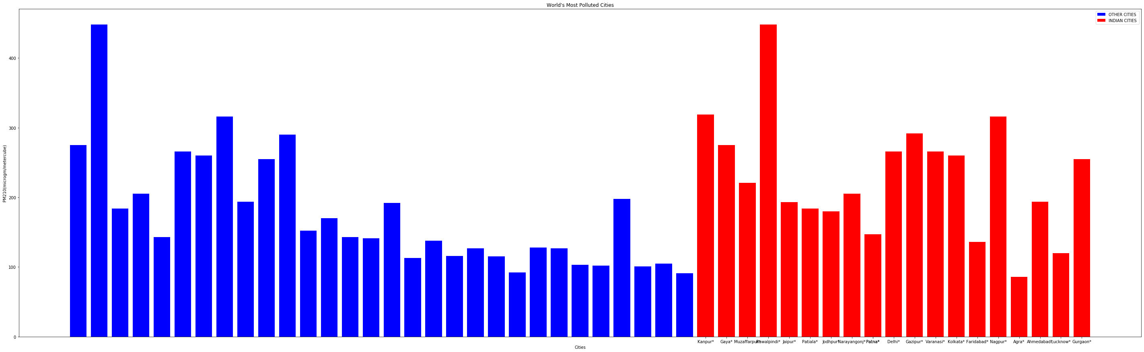
Image:Plotted using python
This plot is based on pollution data of 2017-18 .In the above plot the Red coloured bars indicates Indian Cities and Blue coloured bars represent other cities in the world.This data include top 50 polluted cities in the world .Out of which 19 are from our country.
From this we can conclude that 38% places are occupied by Indian Cities. Pollution in the cities like Kanpur ,Gaya ,Delhi ,Gazipur and Nagpur is the matter of consideration.

"Good" AQI is 0 to 50.Air quality is considered satisfactory, and air pollution poses little or no risk. "Moderate" AQI is 51 to 100.Air quality is acceptable; however, for some pollutants there may be a moderate health concern for a very small number of people. But almost all the Indian cities crosses the moderate AQI level(100μg/m3),And this is not a good sign.

DATA ANALYSIS USING PLOTS
GAYA , NOV 2016

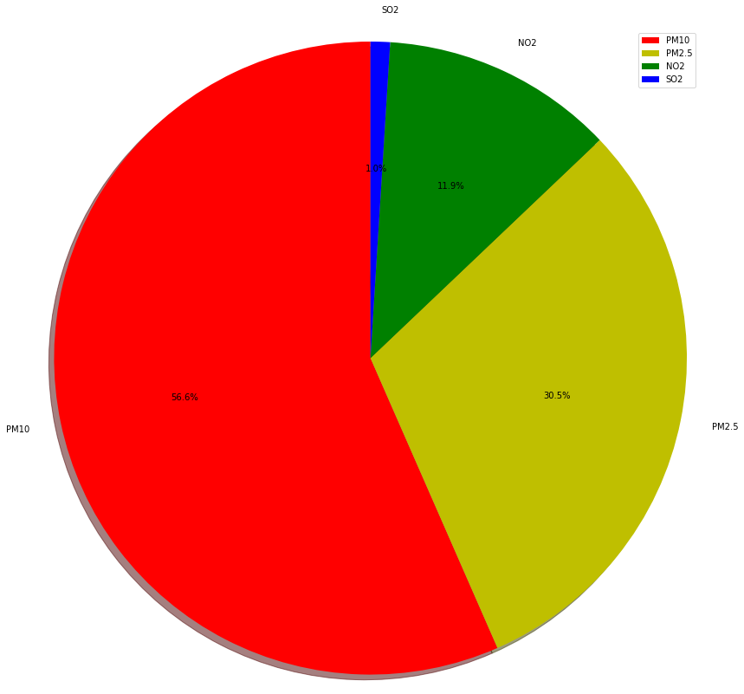

Pie chart 1
Image:Plotted using python

DATA ANALYSIS USING PLOTS
GAYA, NOV 2017

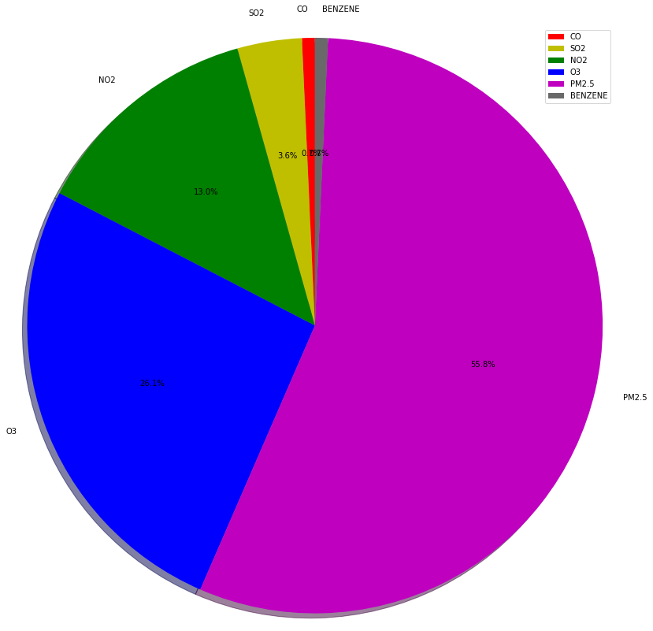

Pie Chart 2
Image:Plotted using python
DATA ANALYSIS USING PLOTS
GAYA, NOV 2019

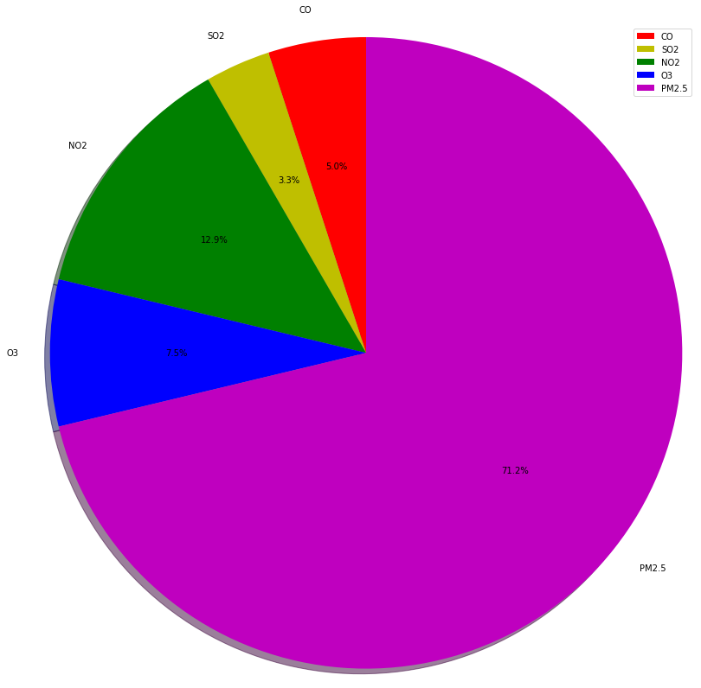
Pie Chart 3
Image:Plotted using python

Analysis:
Pie-chart 1:

This is plot based on pollution data of Nov,2016 of Gaya ,Bihar. Plot shows us that contribution to the pollution is mostly due to PM10(56.6%).PM2.5 and NO2 contributes 30.5% and 11.9% respectively.

Pie-chart 2:

This is plot based on pollution data of Nov,2017 of Gaya,Bihar.
Plot shows us that contribution to the pollution is mostly due to PM2.5(55.8%).O3 and NO2 contributes 26.1% and 13.0% respectively .SO2 and CO are the minor pollutants.

Pie-chart 3:

This is plot based on pollution data of Nov,2019 of Gaya,Bihar.
Plot shows us that contribution to the pollution is mostly due to PM2.5(71.2%). NO2 and O3 contributes 12.9% and 7.5% respectively.SO2 and CO are the minor pollutants.

From Above Analysis we can conclude that PM2.5 causes more pollution in the city. SO2 and CO are the minor ones. Concentration of PM2.5 is increasing at very rapid rate .
and at the current stage it’s concentration is 71% ,which is so high ,that it can cause the harmful breathing diseases such as chronic obstructive pulmonary disease-COPD.When breathed in they penetrate deep into the lungs. Exposure to high concentrations of PM10can result in a number of health impacts ranging from coughing and wheezing to asthma attacks and bronchitis to high blood pressure, heart attack, strokes and premature death.

SOLUTION:
Because particle pollution from the outdoor air can easily get inside, take steps to avoid adding even more pollution indoors when outdoor PM2.5 levels are high:
1)Avoid using anything that burns, such as wood fireplaces, gas logs and even candles or incense
2)Keep the room clean – but don’t vacuum unless your vacuum has a HEPA filter. That stirs up particles already inside your home. Wet mopping can help reduce dust
3)Don’t smoke.
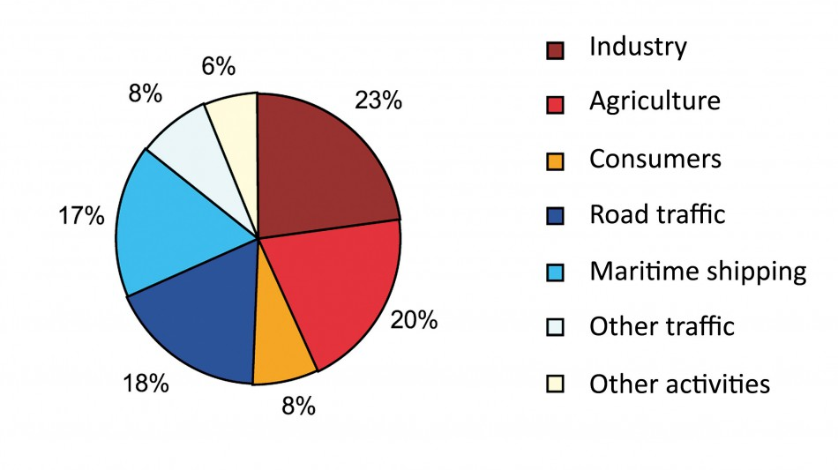
4)Be cautious when the weather is hot. If it is too hot to stay inside with the windows closed, or if you are in an at-risk group, go somewhere else with filtered air.

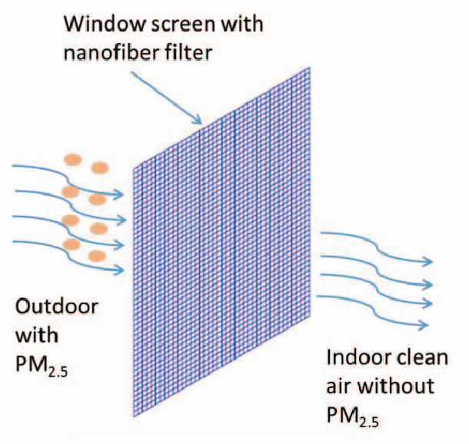
5)When air quality improves, open the windows and air out your home or office.
6)HEPA PURIFIER:
The most common type of air purifier used to remove pollutants from traffic and other PM2.5 sources is one with a HEPA filter inside (HEPA stands for High Efficiency Particulate Arrestor).

SOLUTION FOR PM10:

7)Installation of DOC and DPF devices in all pre-2010 diesel vehicles 13.0%
7)No power cuts leading to zero usage of DG sets 12.8%.

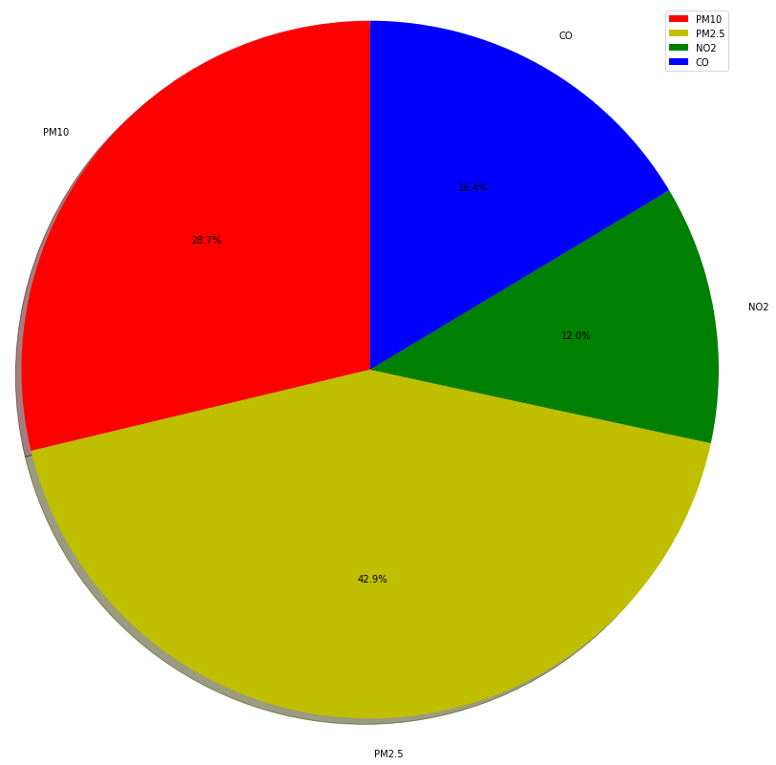
DATA ANALYSIS USING PLOTS
DELHI, NOV 2013

Pie-chart1

Image:Plotted using python

DATA ANALYSIS USING PLOTS

DELHI, NOV 2015

Pie-chart 2
Image:Plotted using python

DATA ANALYSIS USING PLOTS
DELHI, NOV 2019

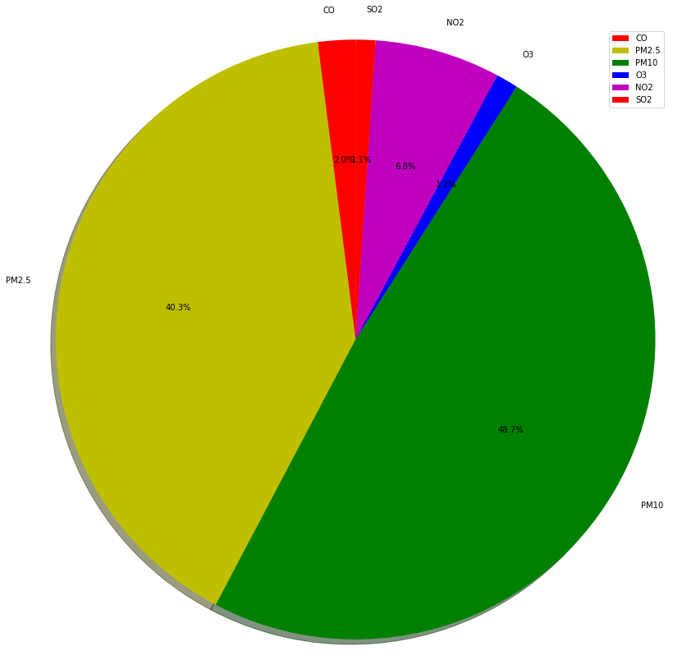
Pie-chart 3
Image:Plotted using python

DATA ANALYSIS USING PLOTS
Analysis:
Pie-chart 1:

This is plot based on pollution data of Nov,2013 of Delhi.
Plot shows us that contribution to the pollution is mostly due to PM2.5(42.9%).PM10 and CO contributes 28.7% and 16.4% respectively.

Pie-chart 2:

This is plot based on pollution data of Nov,2015 of Delhi.
Plot shows us that contribution to the pollution is mostly due to PM10(56.6%).PM2.5 and NO2 contributes 30.5% and 11.9% respectively.SO2 is the minor pollutant.

Pie_chart 3:

This is plot based on pollution data of Nov,2019 of Delhi.
Plot shows us that contribution to the pollution is mostly due to PM10(48.7%). PM2.5 and NO2 contributes 40.3% and 6.8% respectively.SO2 and CO are the minor pollutants.

From above analysis we can conclude that the concentration of PM2.5 is continuously increasing from year 2013 to 2019.Still the level of PM10 is higher than that of PM2.5 . NO2 holds third place. SO2 and CO are minor contributors to the pollution in Delhi.

Effects:

Nitrogen dioxide causes a range of harmful effects on the lungs, including:
1)Increased inflammation of the airways;
2)Worsened cough and wheezing;
3)Reduced lung function;
4)Increased asthma attacks; and.
5)Greater likelihood of emergency department and hospital admissions.

SOLUTION :
A)FOR NO2 EMMISION

1)When air quality is healthy, bike or walk instead of driving.
2)Combine errands to reduce vehicle trips.
3)Limit engine idling.
4)When refueling, avoid spilling fuel. .
5)Keep your car, boat, and other engines tuned up.

